Topics:-

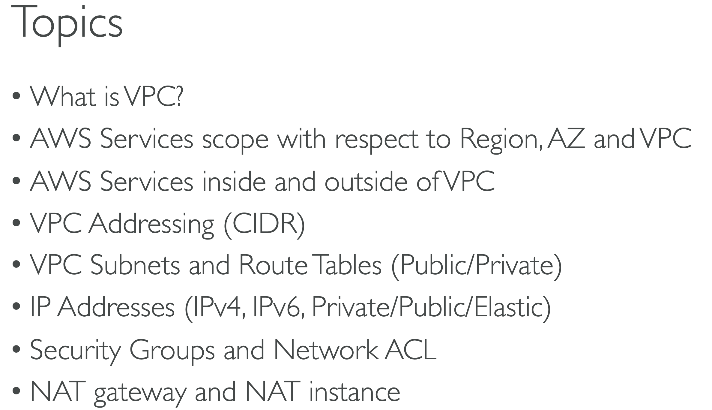

VPC: Virtual Private Cloud

Traditional Vs Virtual Network in Cloud

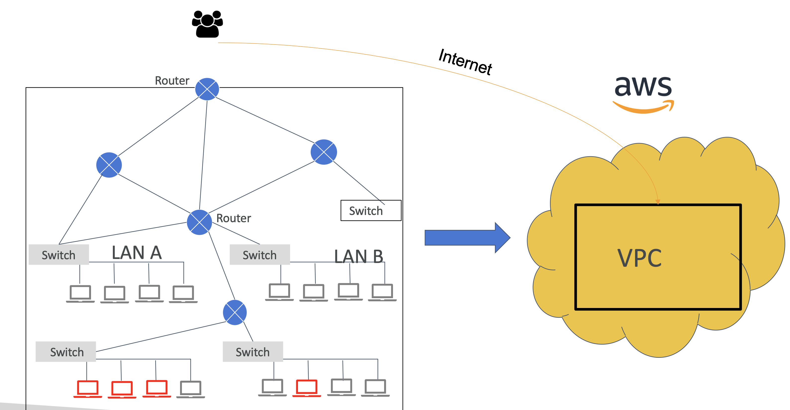

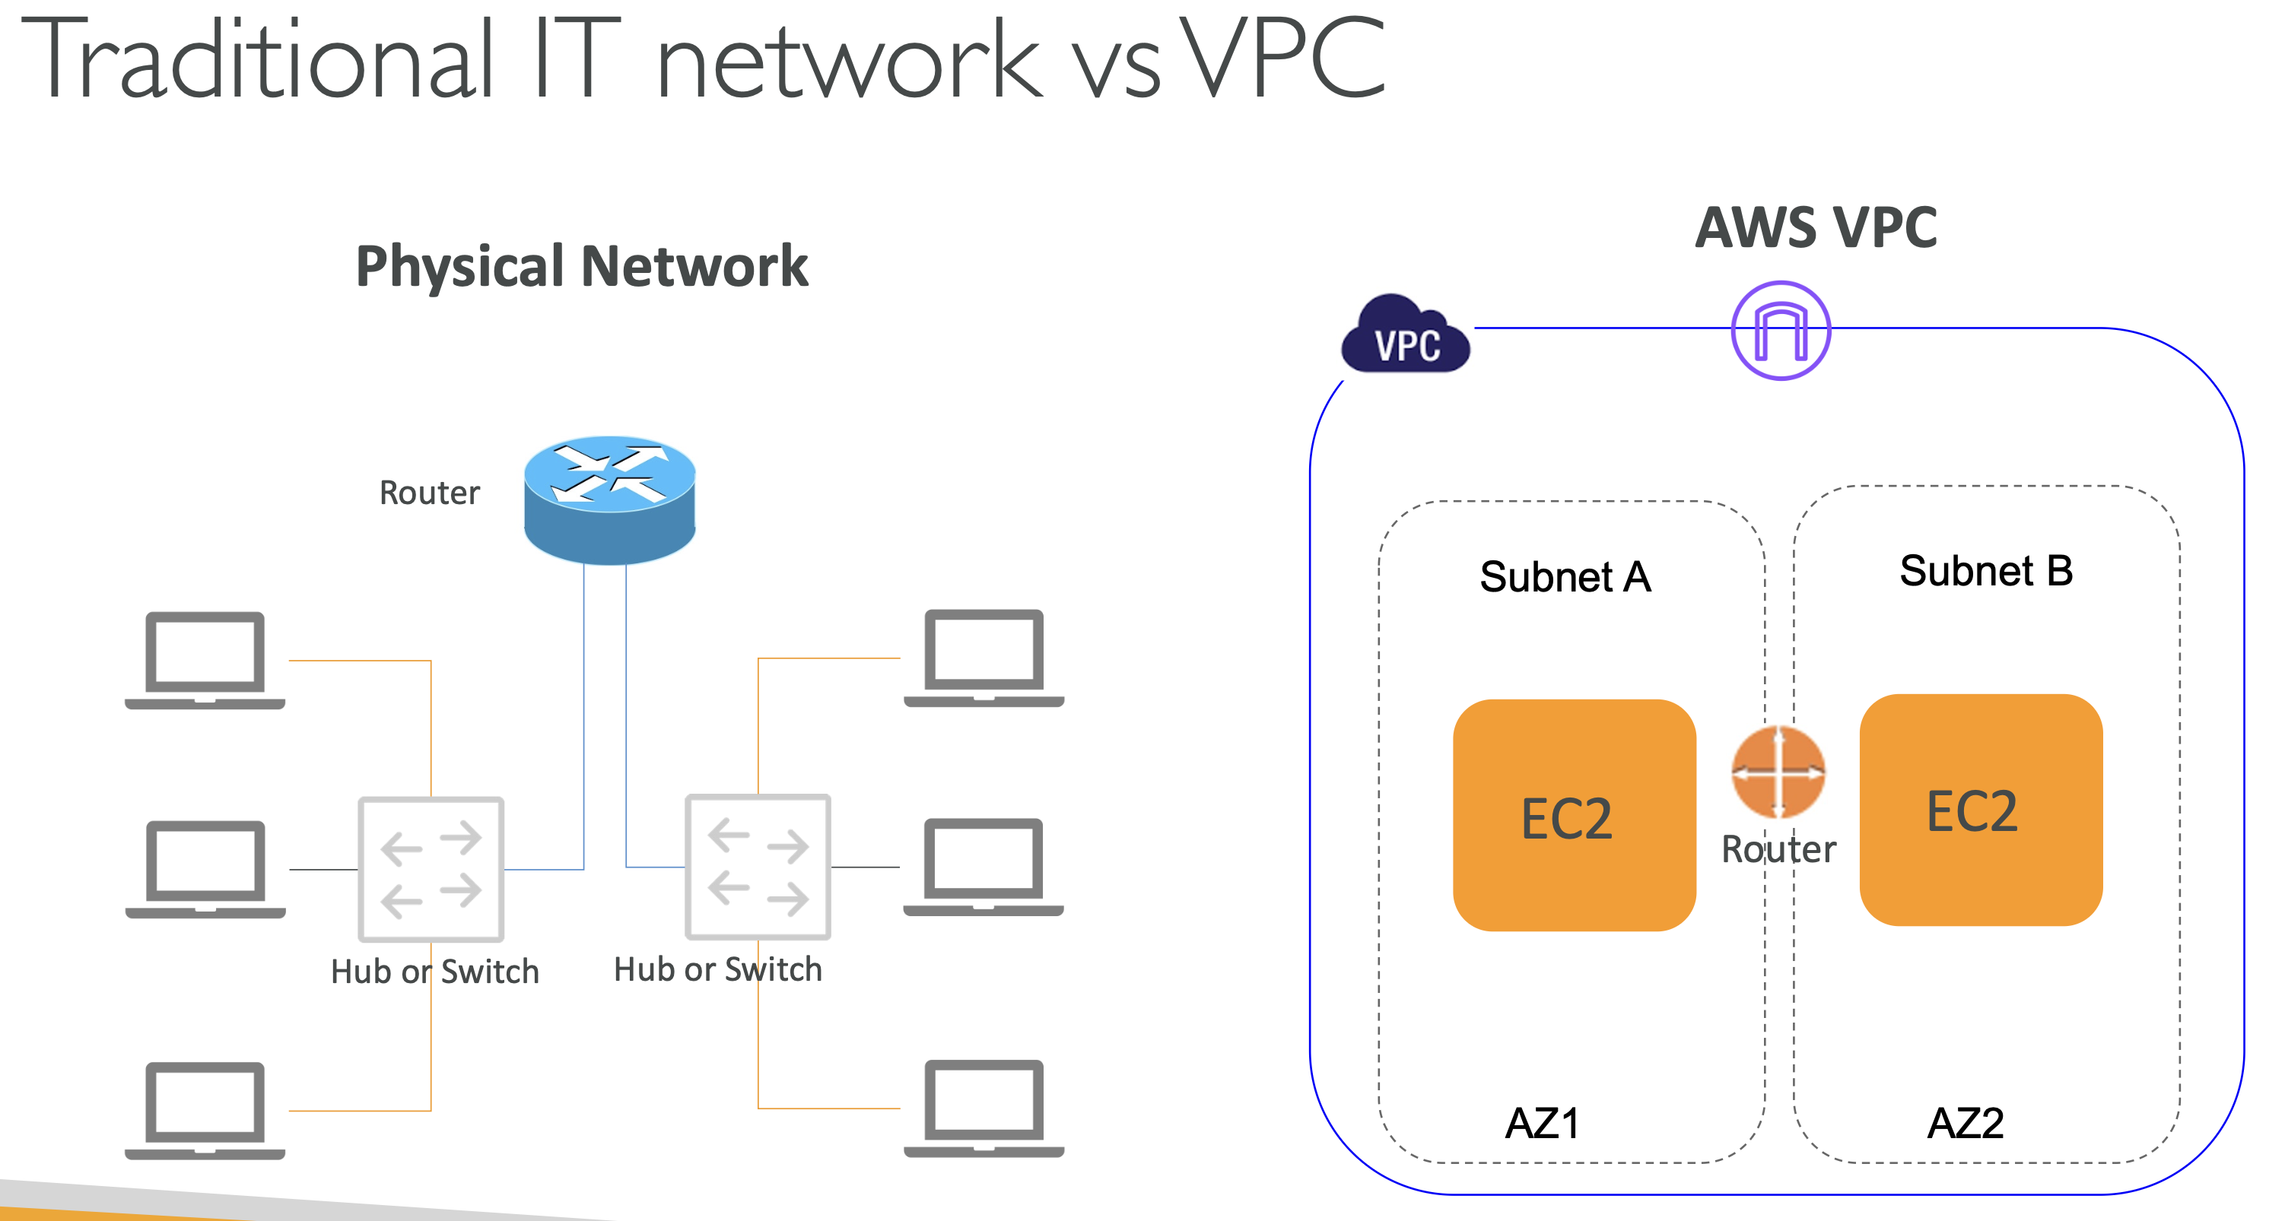

VPC is region scoped

One region can have many VPCs

One VPC can have many AZz

**Subnet mapped with AZ (Availability Zone). A single subnet cannot span across multiple AZs. One subnet is mapped with a single AZ.**

One VPC can have many Subnets

EC2, RDS -> AZ scoped i.e deployed on a given subnet

ELB (Elastic Load Balancer) -> VPC scoped

S3 is region scoped, fully managed by AWS, hence not placed in any VPC.

Route 53 i.e DNS Service is Global scoped. Not sits in particular region and operate globally.

IAM, Billing service are Global scope

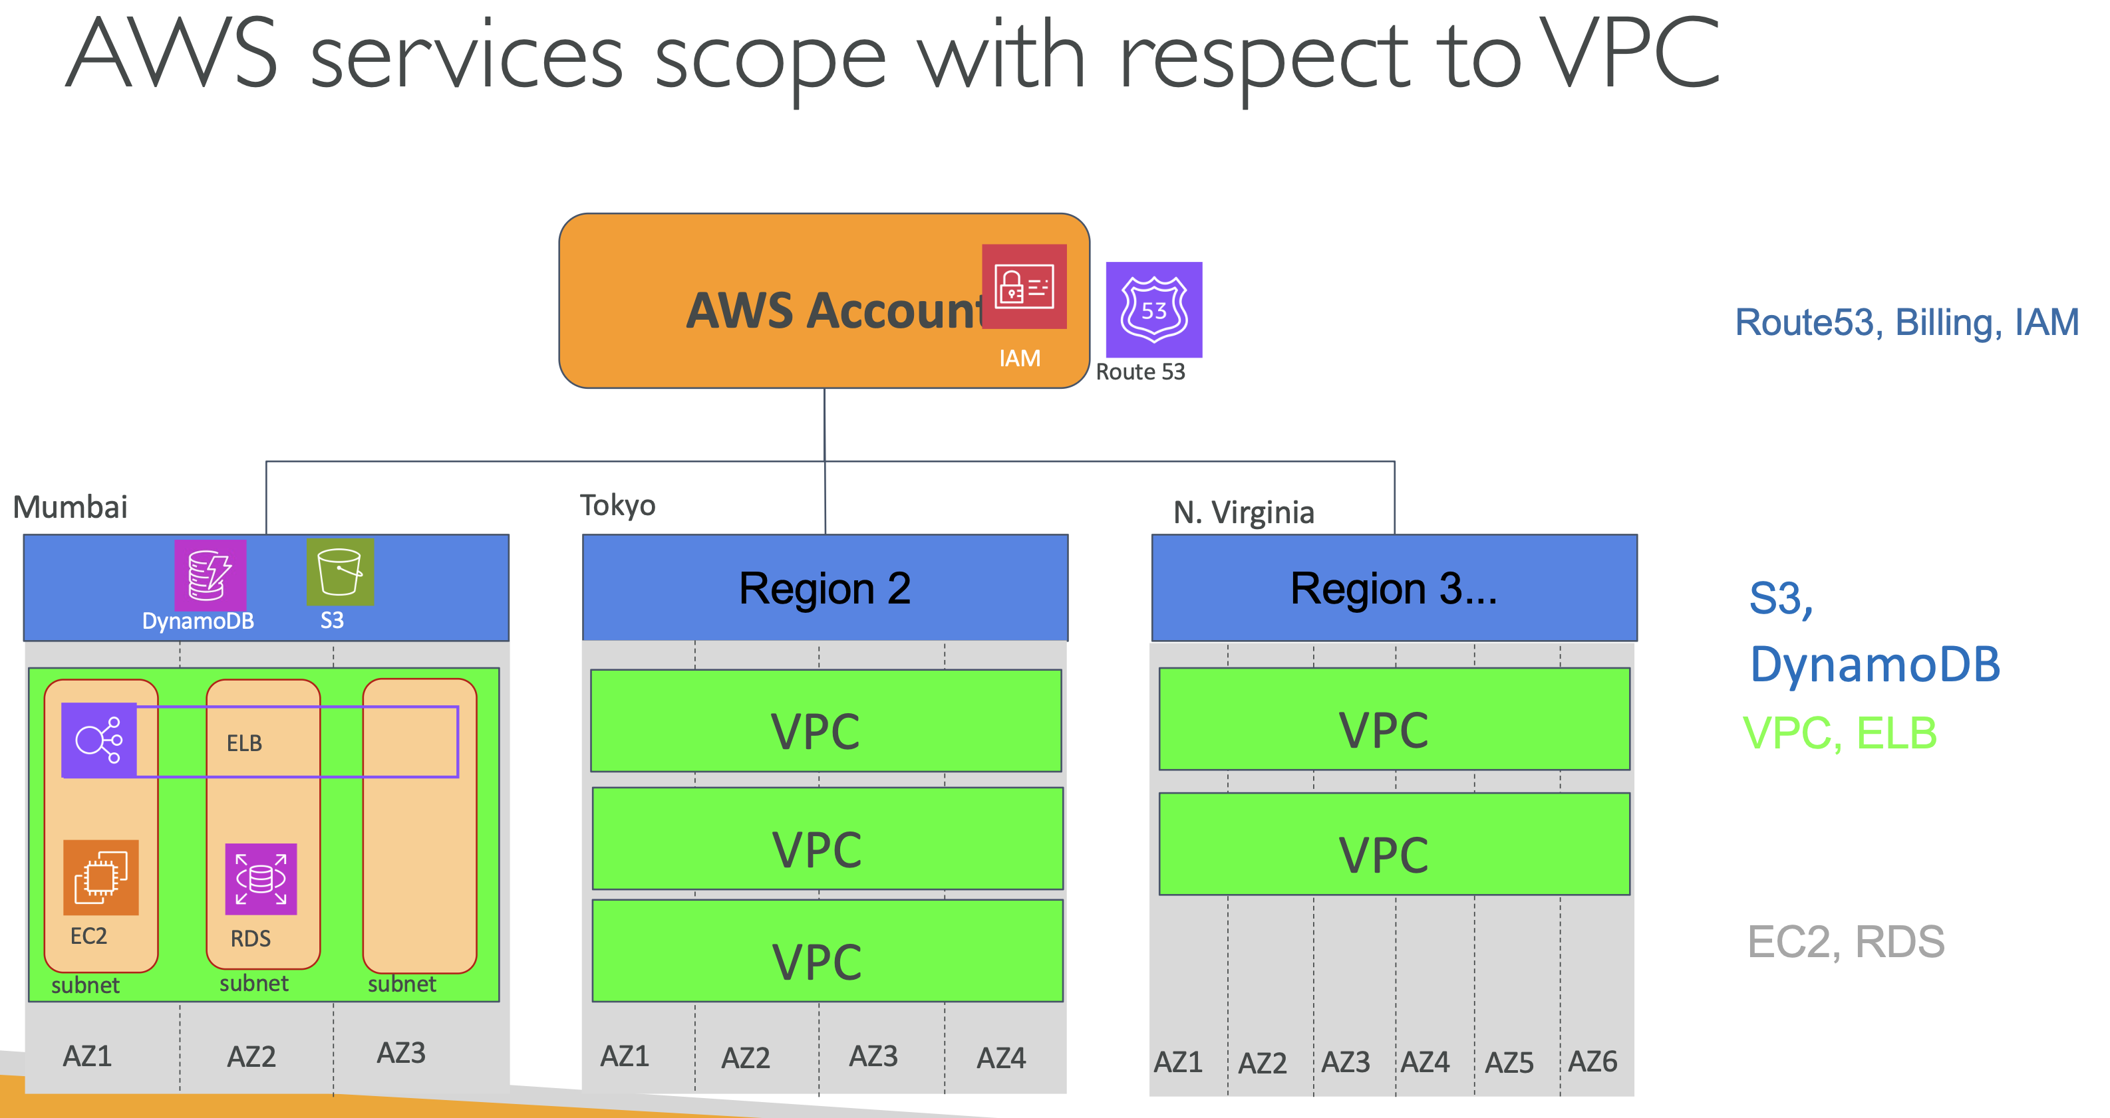

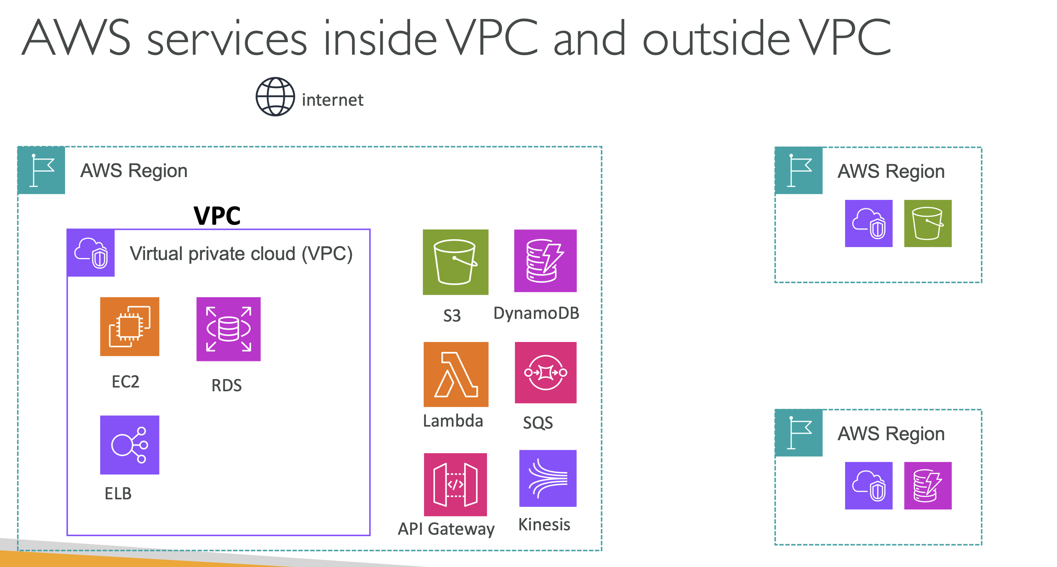

VPC Building Blocks:-

CIDR

Subnets

Route Tables ( VPC level, Subnet level)

**2 Firewalls for VPC : -**

1. Security Group (We can have multiple SGs in one VPC. SG works at EC2 instance level)
2. Network ACL (at Subnet level)

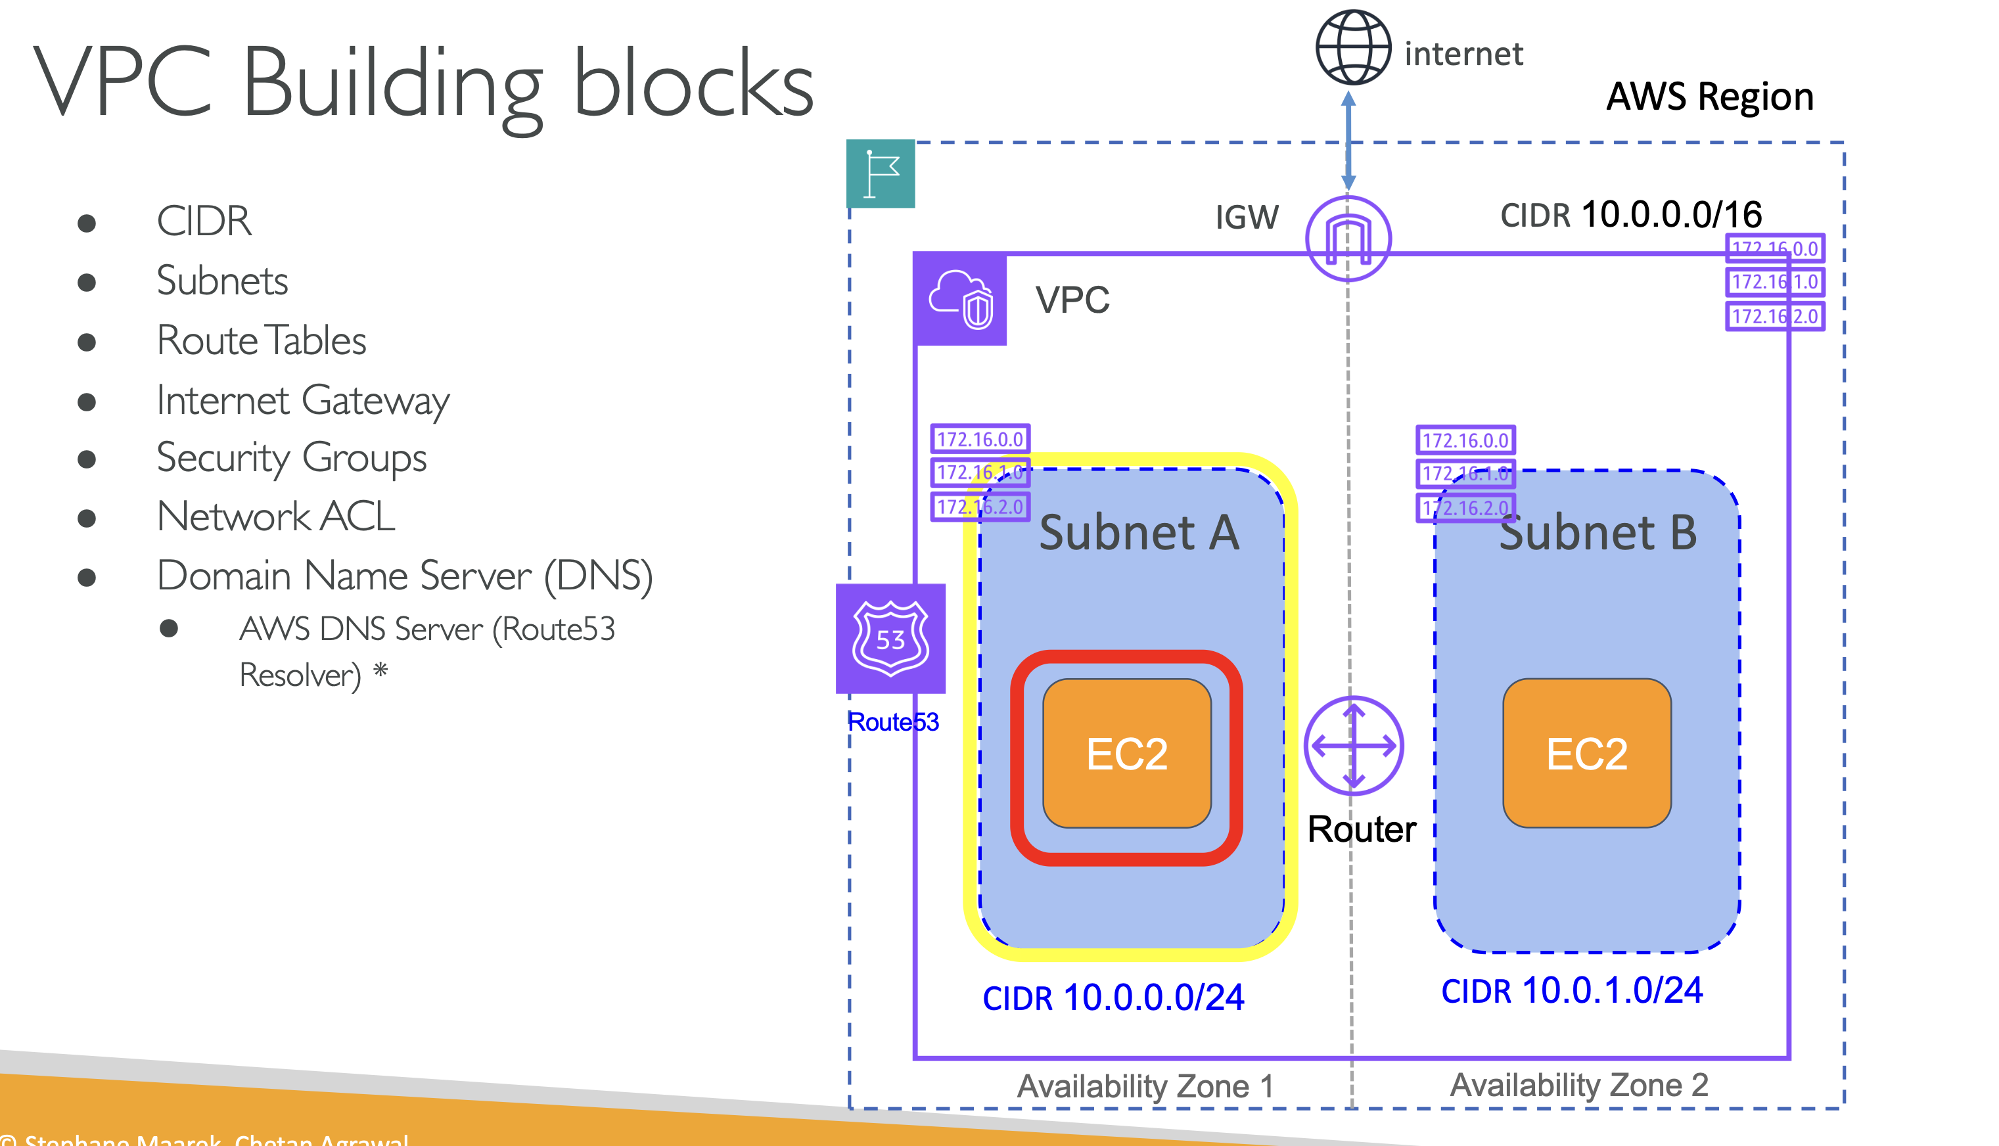

VPC CIDR (Classless Interdomain Routing) :-

IPv4 32 bits -> 2 ^ 32 ip addresses

IPv6 128 bits -> 2 ^ 128 ip addresses

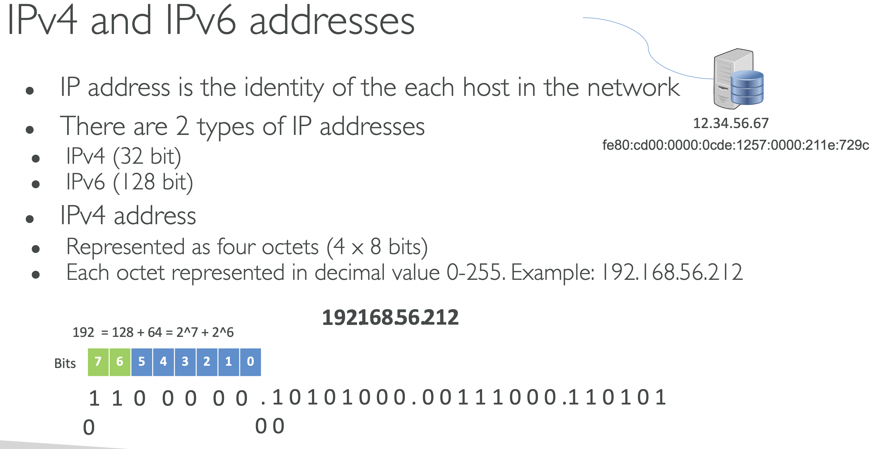

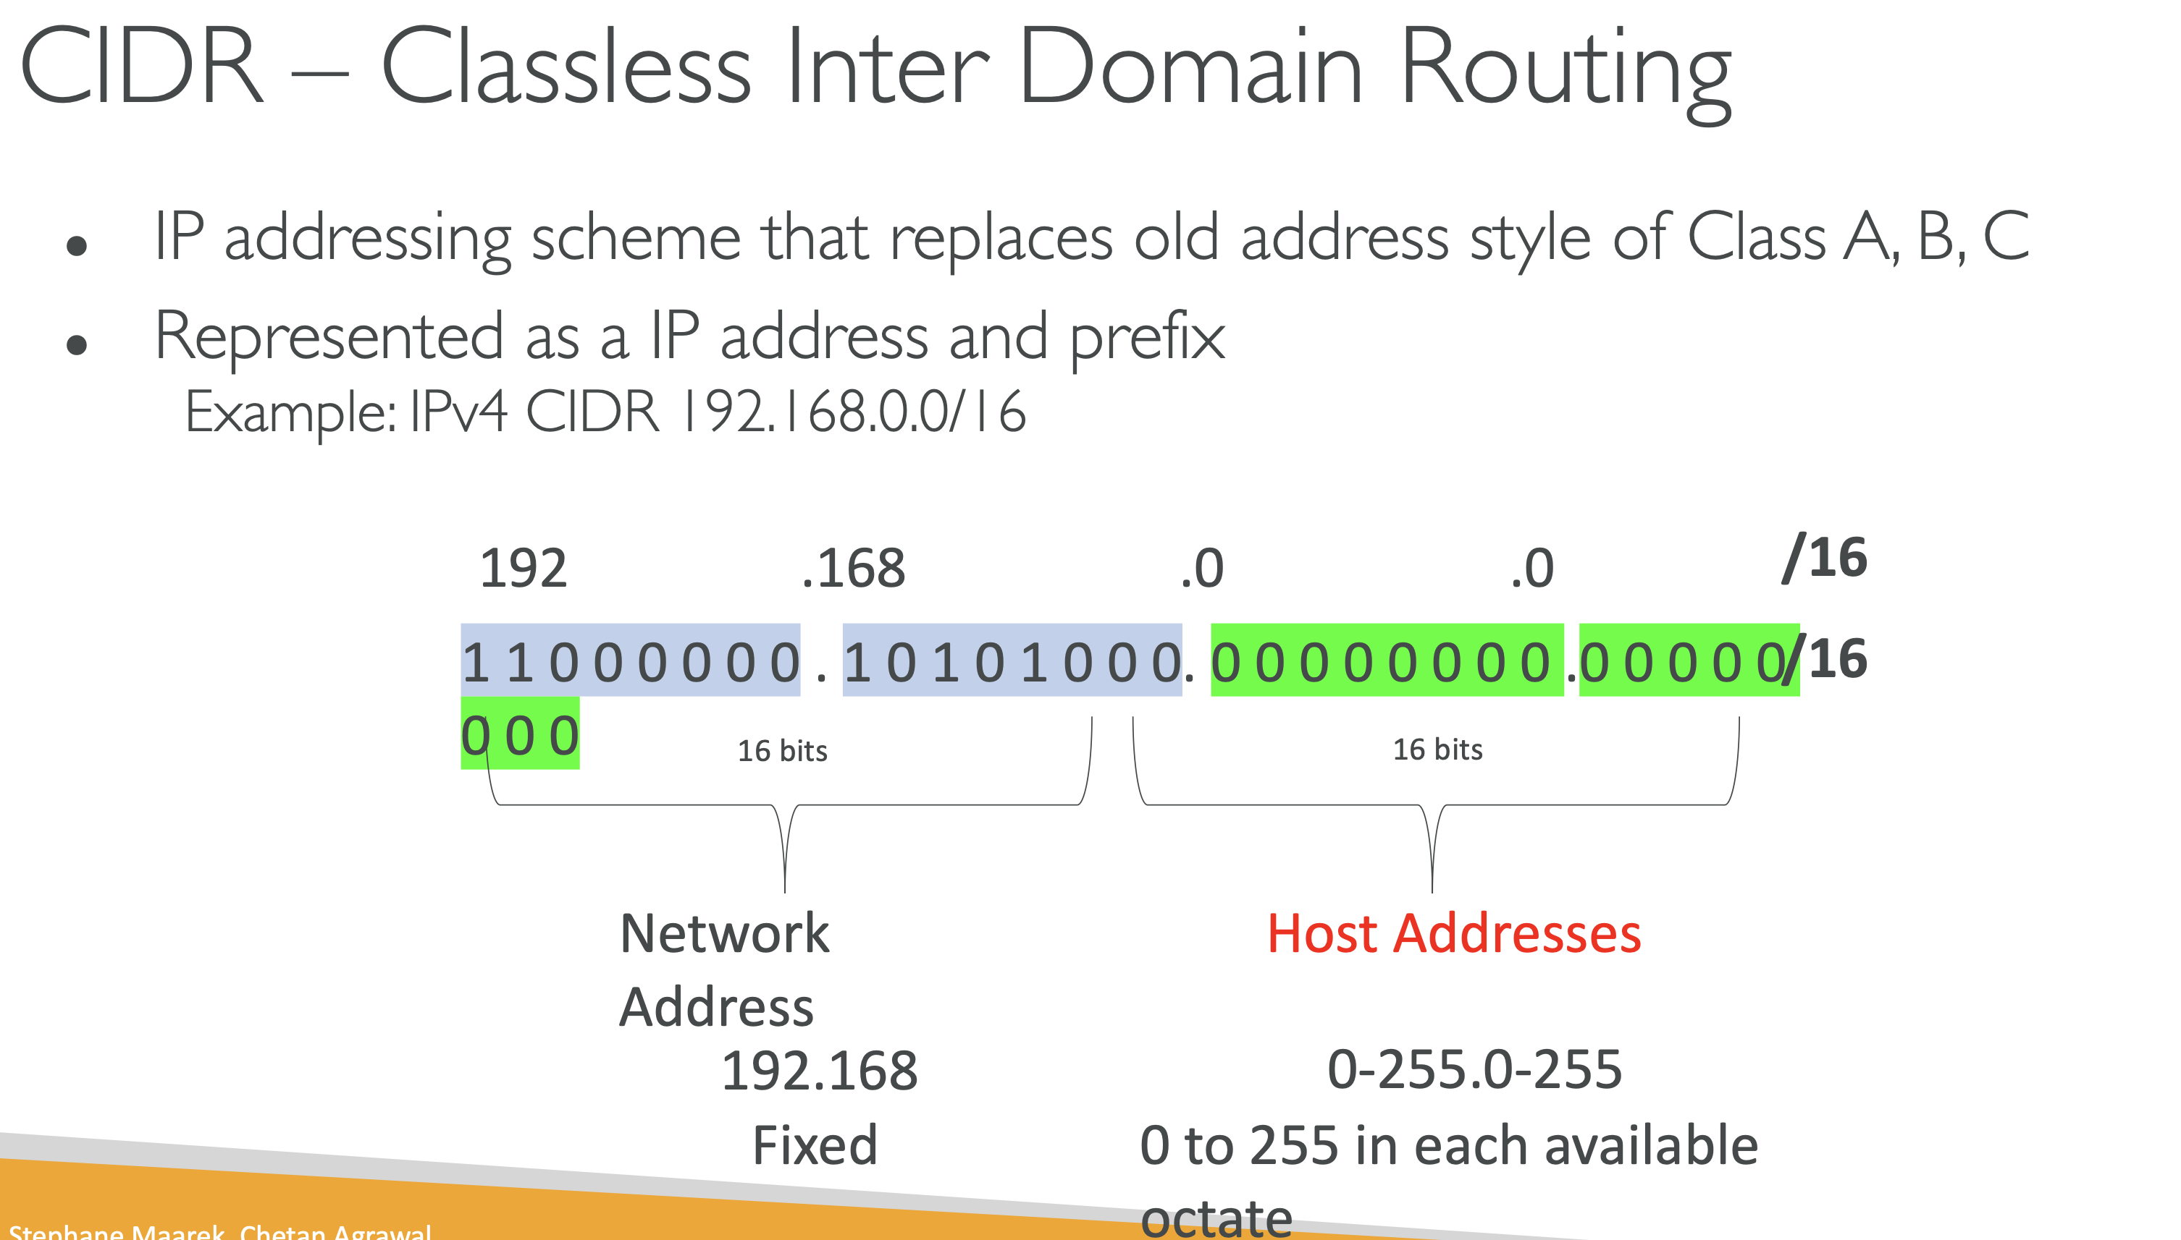

**Prefix /16 represents network bits.**

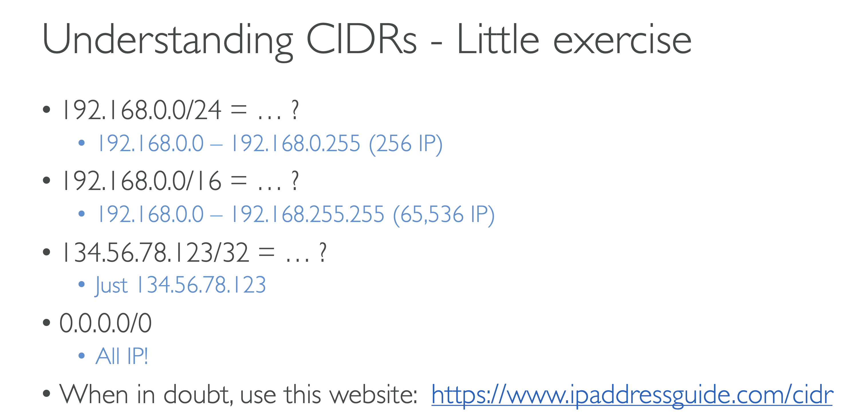

**VPC Route Tables**

Now when you create a VPC it also creates two things for you.

1. Local Router
2. VPC Main Route Table

One there is a local router. Now this router is responsible for all the communication between all the subnets within the VPC. And then there is a main route table which actually contains the rule which dictates how the traffic would flow between the subnets inside a VPC.

So what you do is you create multiple subnets.

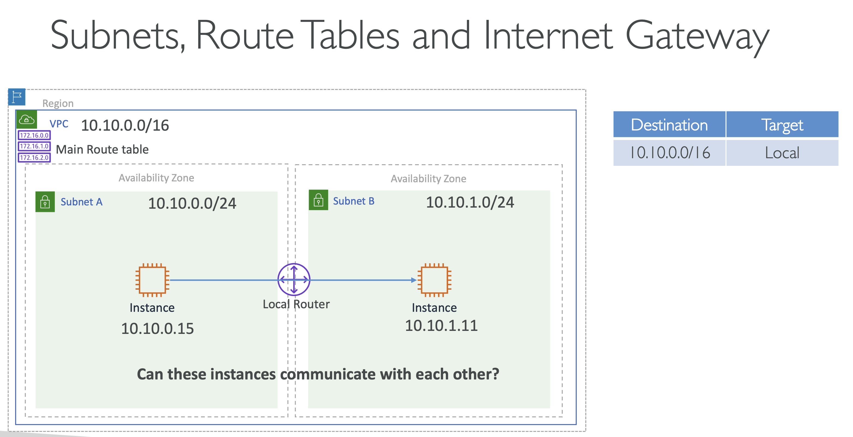

By default, whenever you create a VPC and you create multiple subnets, every instance in every subnet can communicate with any other instance in any other subnet. That's because there is always this rule in all the route tables within the VPC.

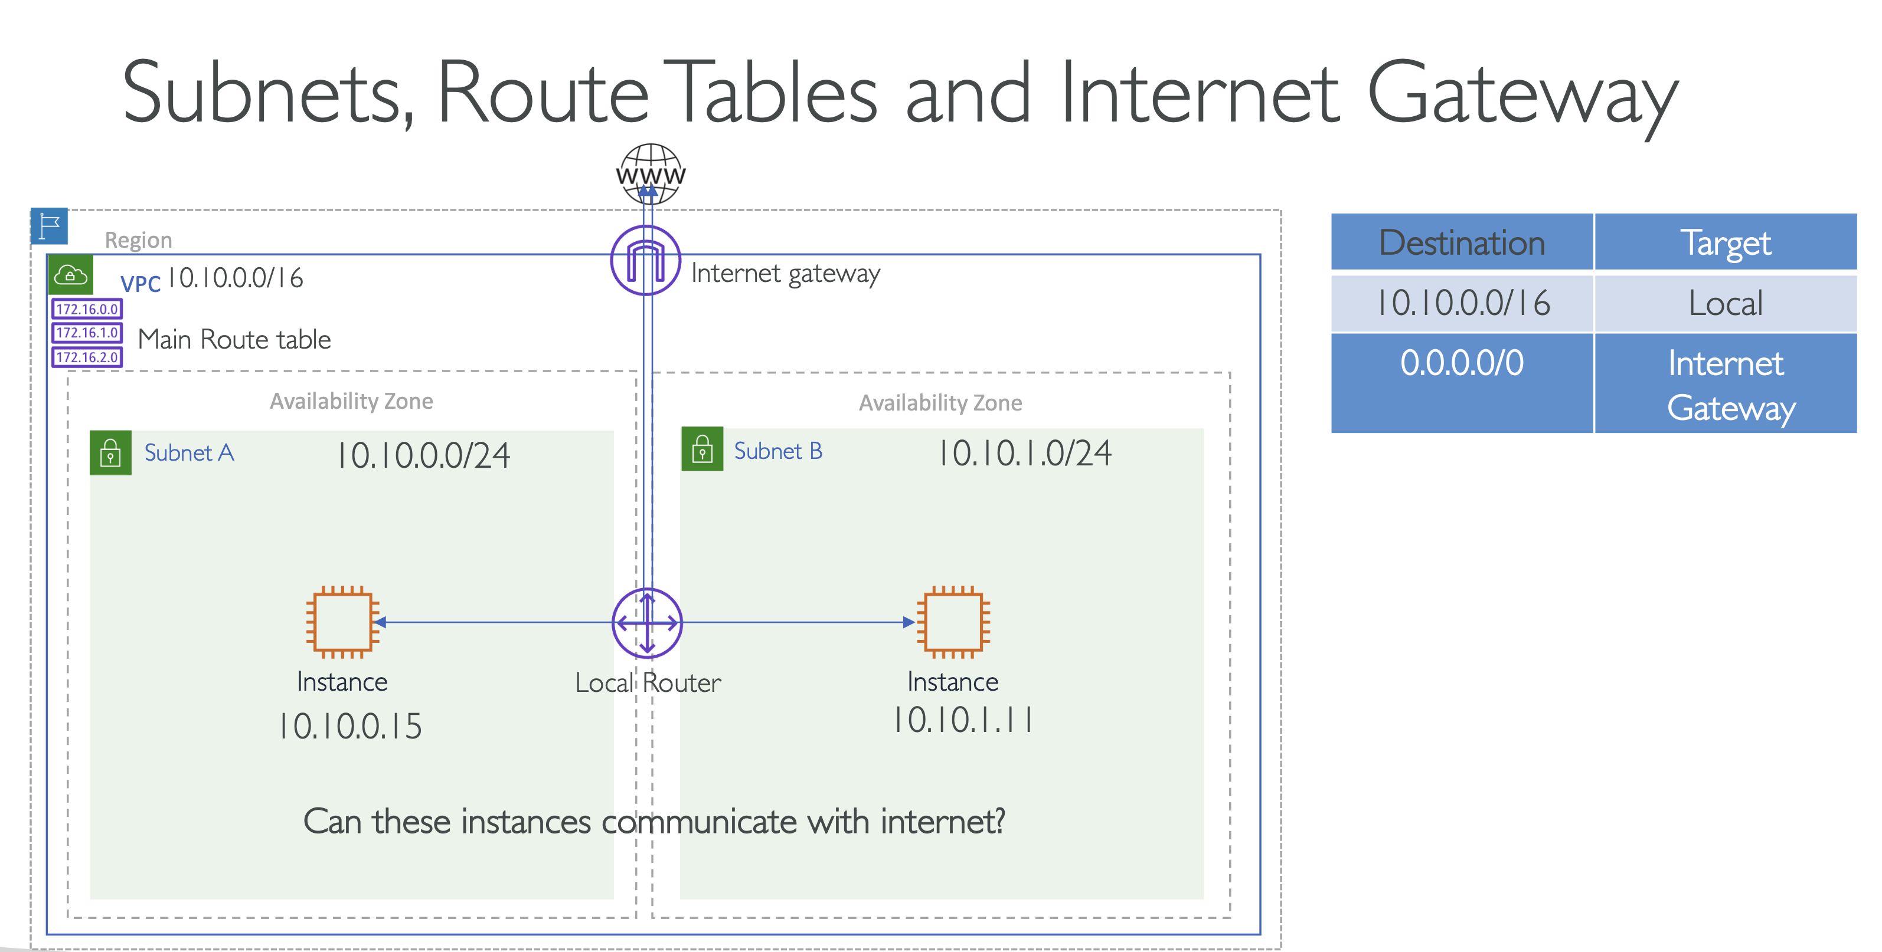

Very important:-

All the subnets in a VPC follow main VPC route table. And lets say below is the main route table for VPC:

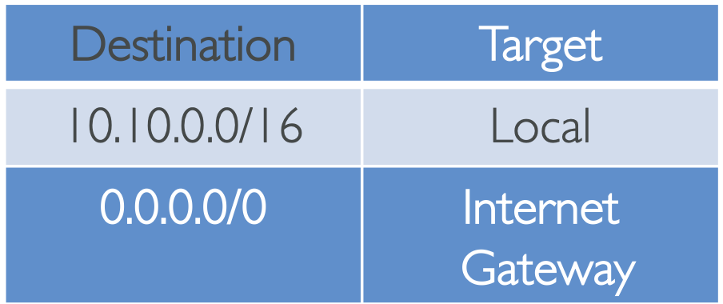

**Then all the subnets in a VPC will have access to the Internet through the Internet Gateway.**

**But, lets say you want only one of the subnets to talk to the internet, you can create a custom route table for that subnet and for routing purpose only this will be referred and not the main route table for VPC.**

**If no route table exists for a given subnet, it follows main route table for VPC.**

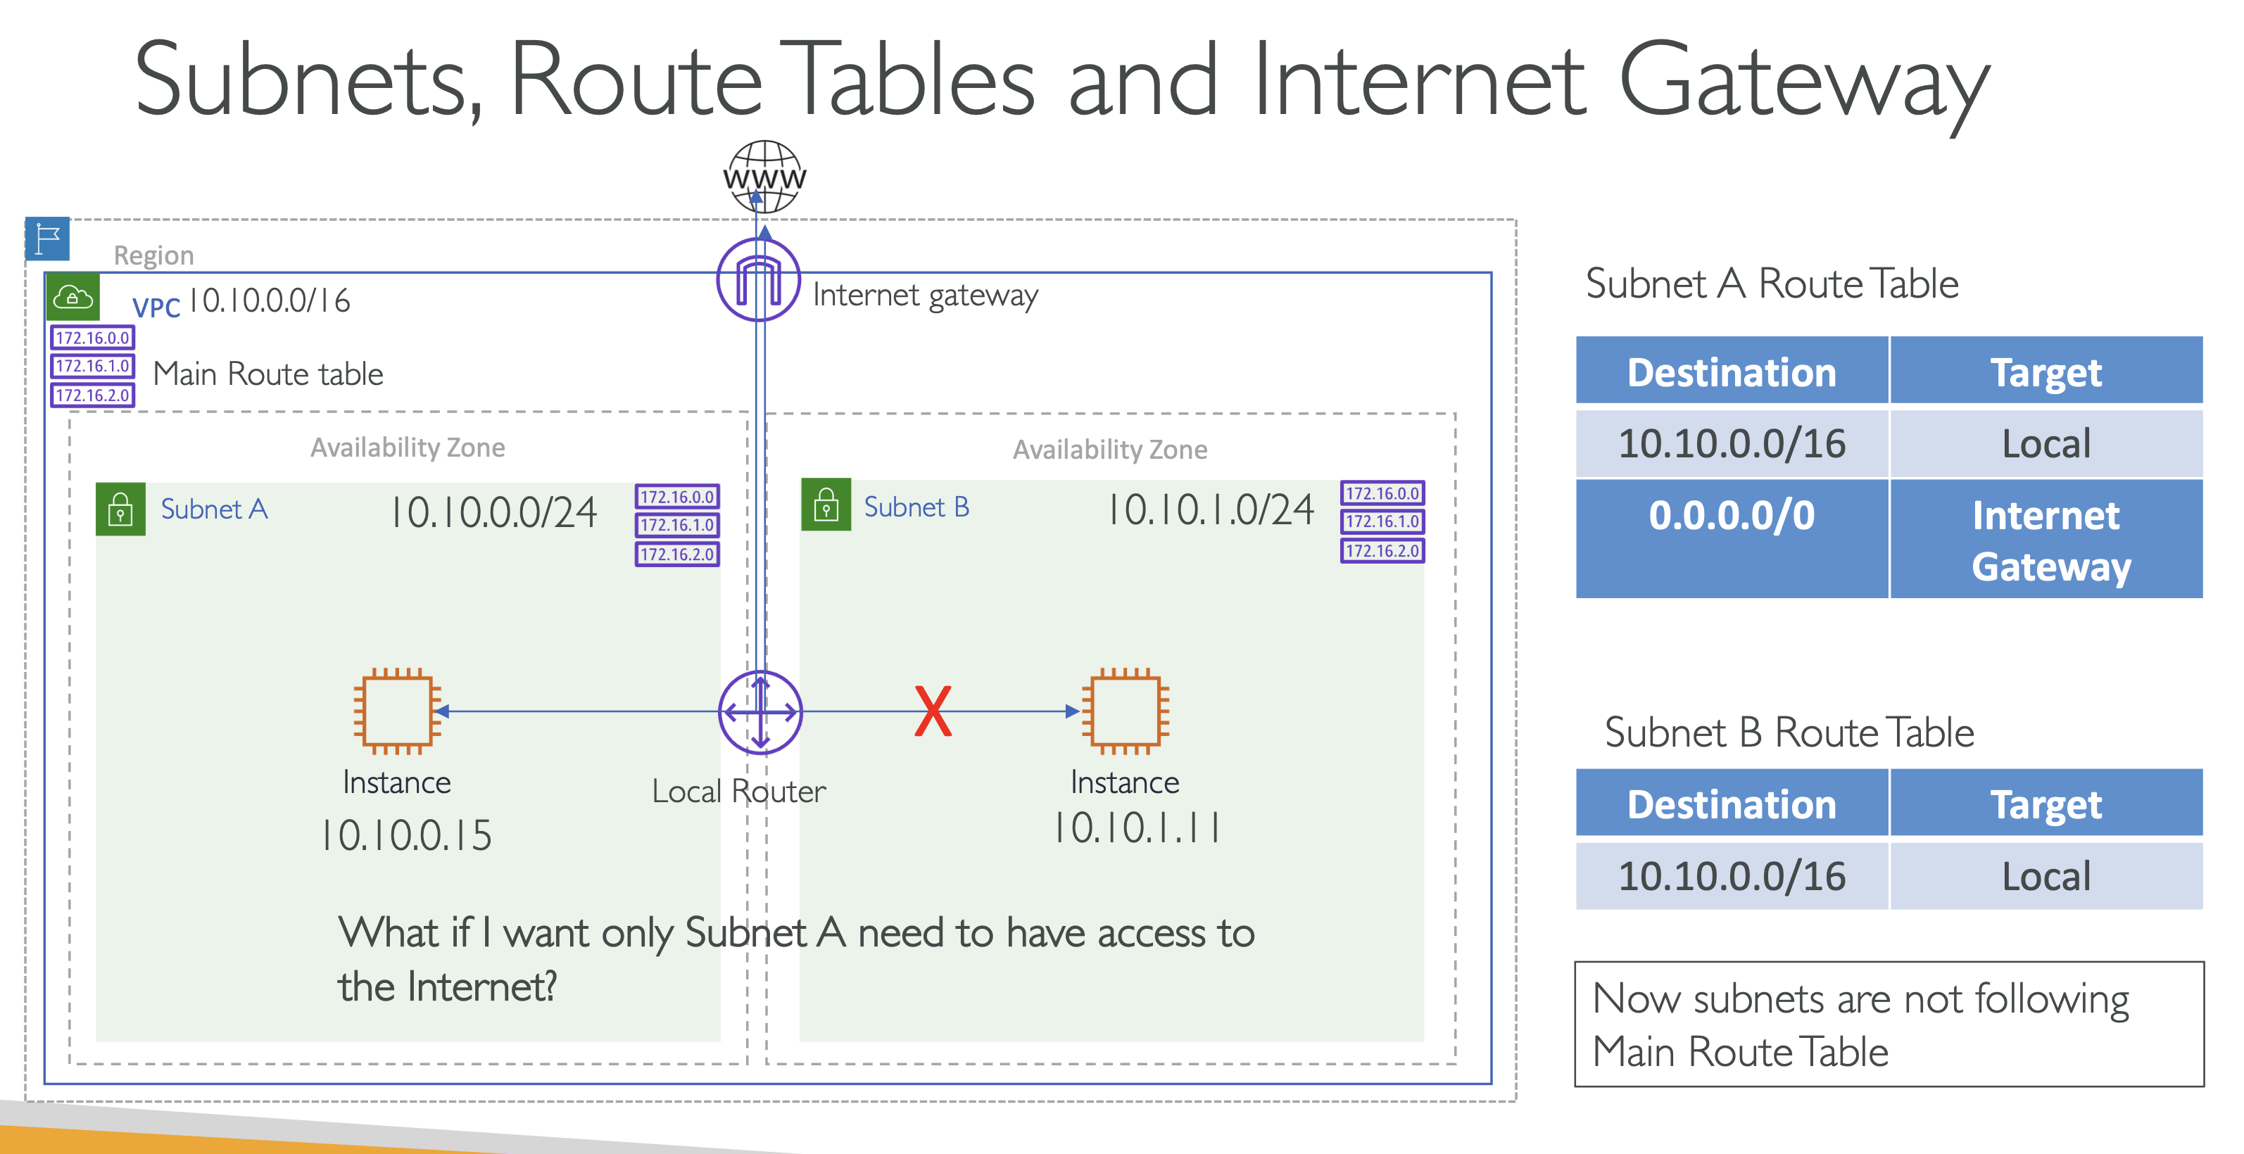

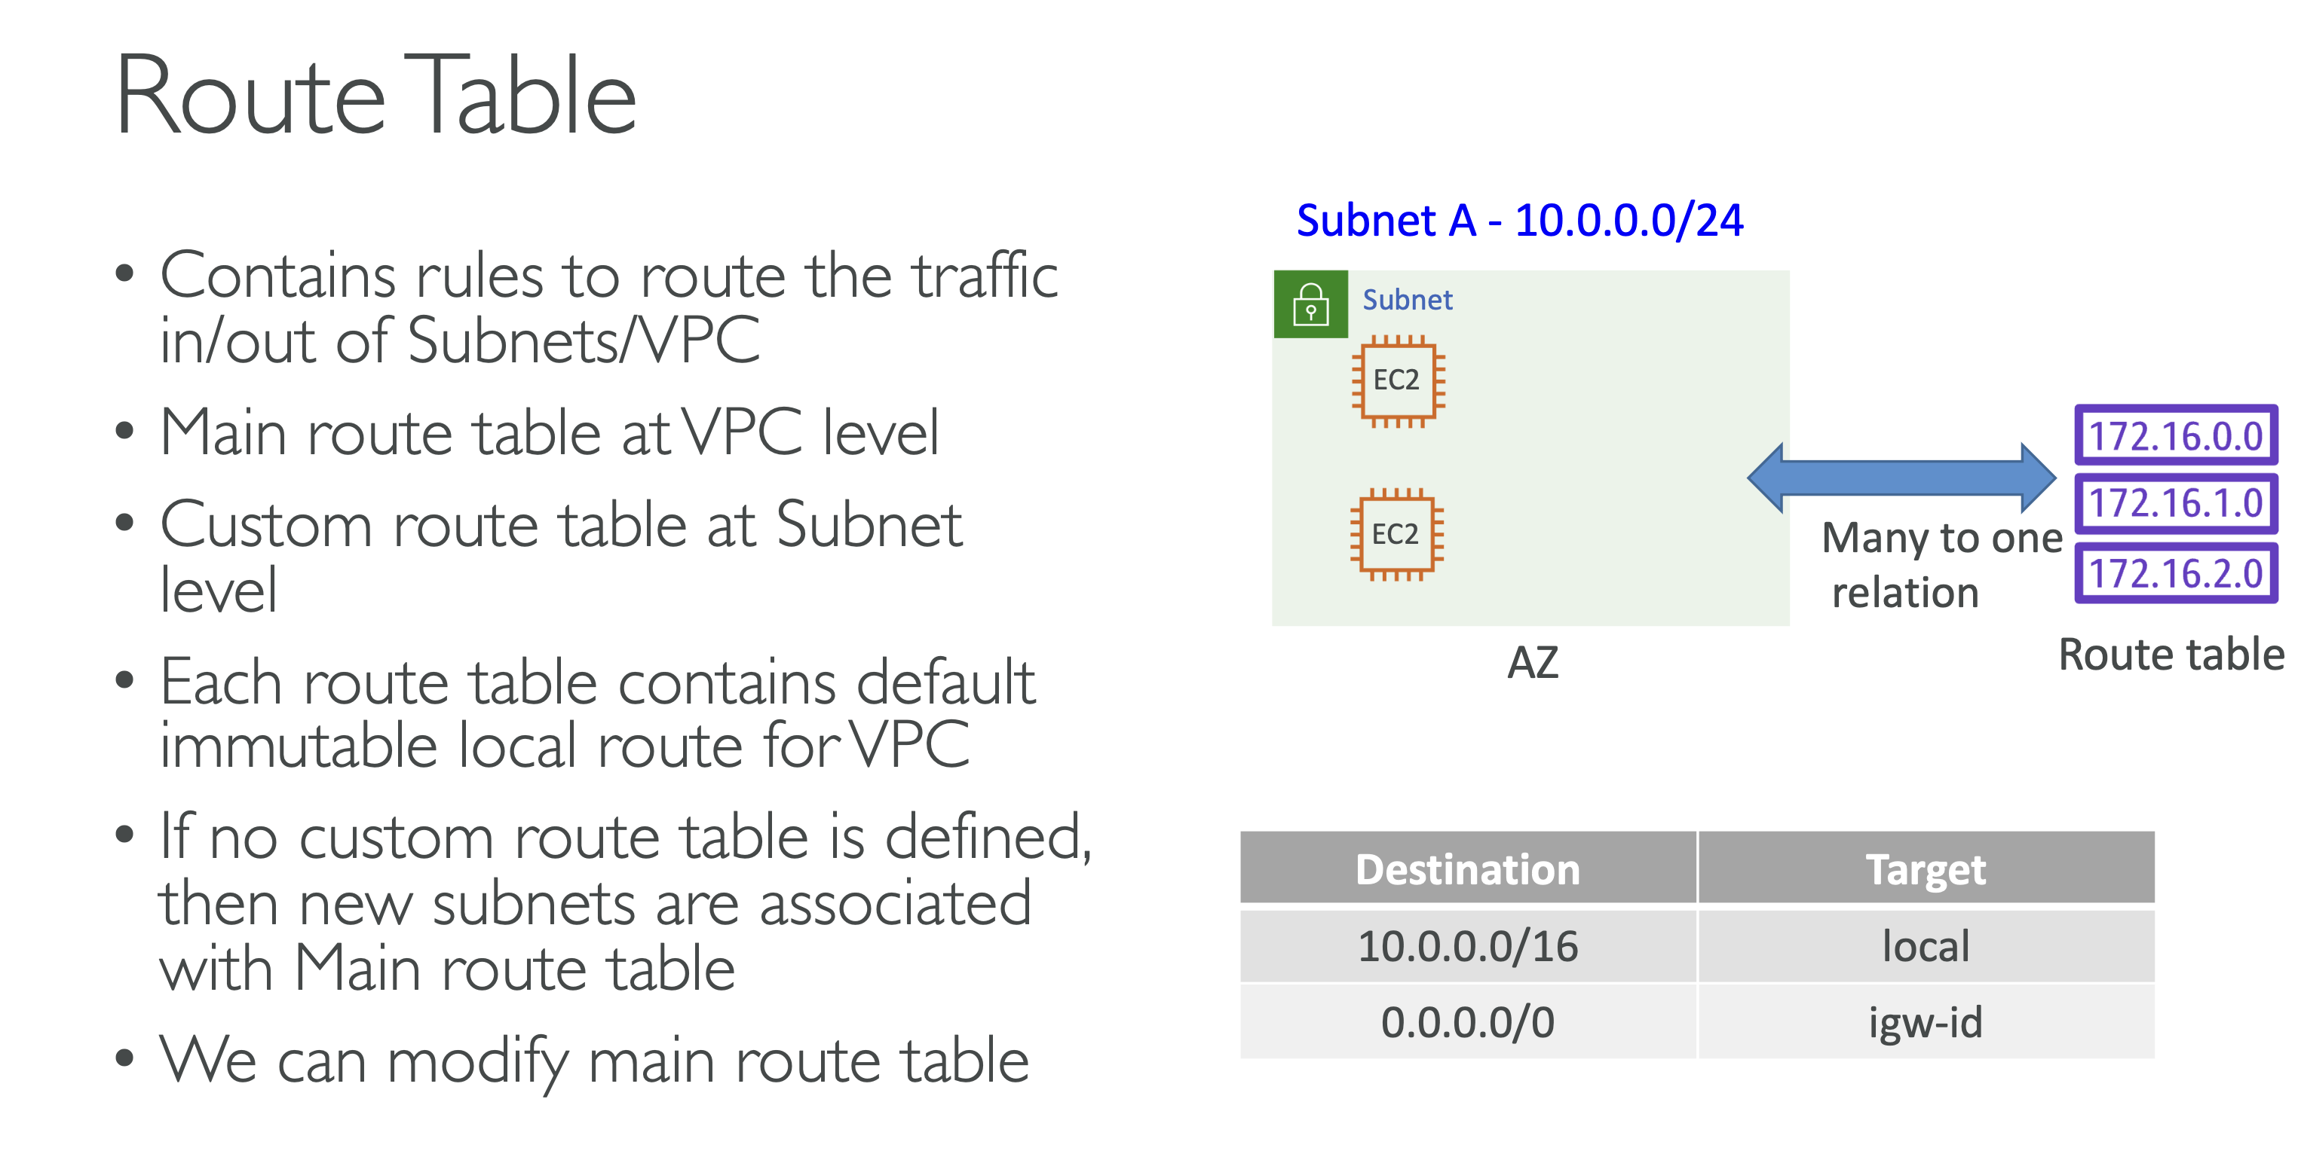

**Public and Private subnets are classified based on the Internet gateway route entry in route table.**

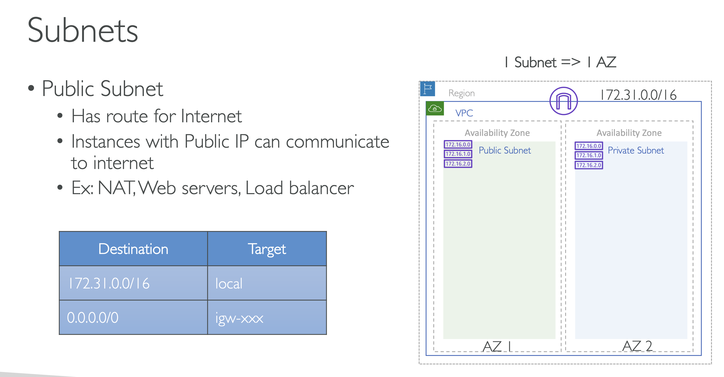

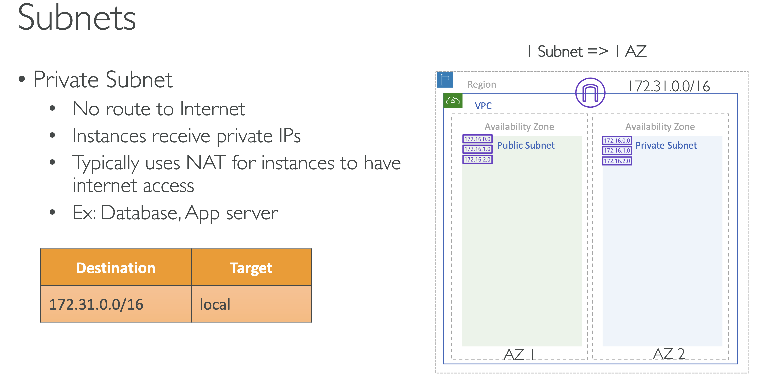

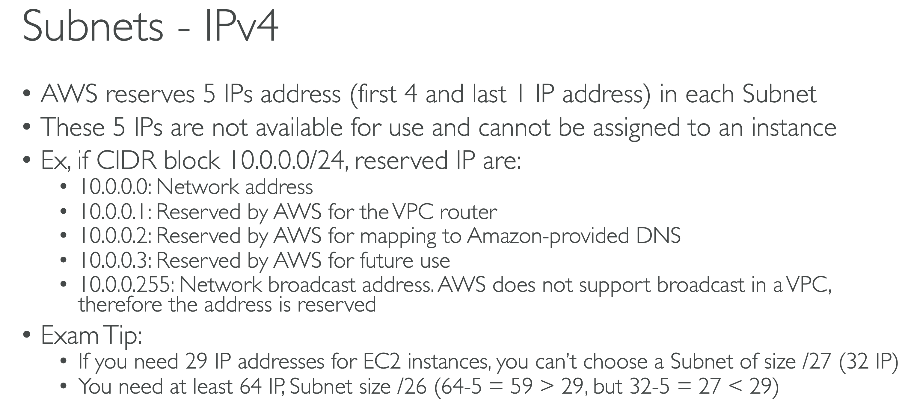

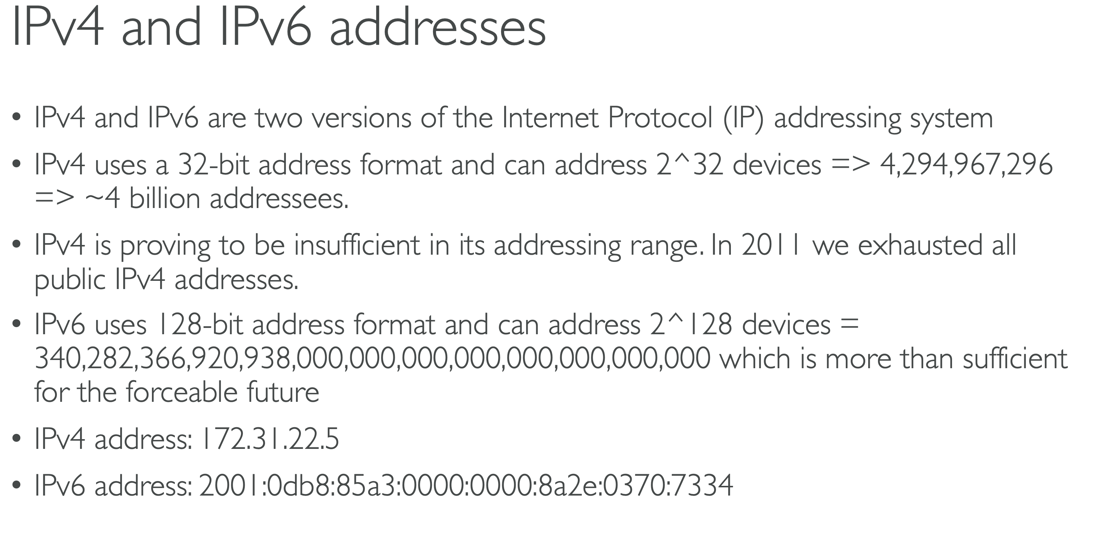

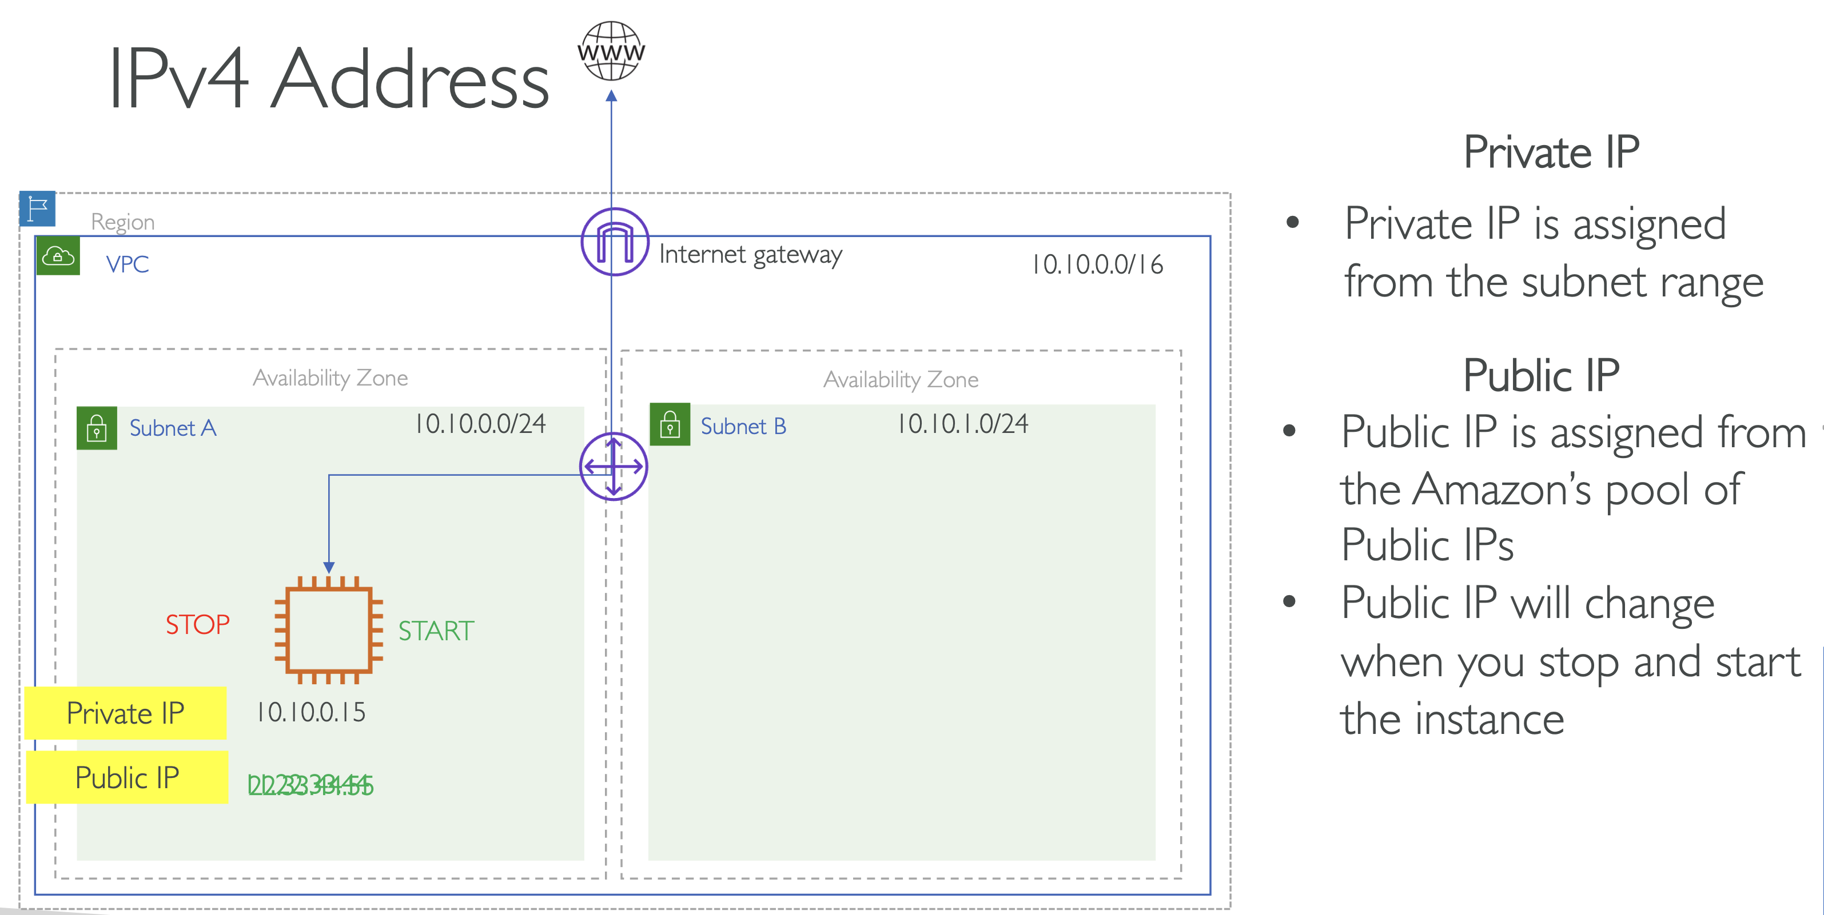

Elastic Ips = Static Public Ips

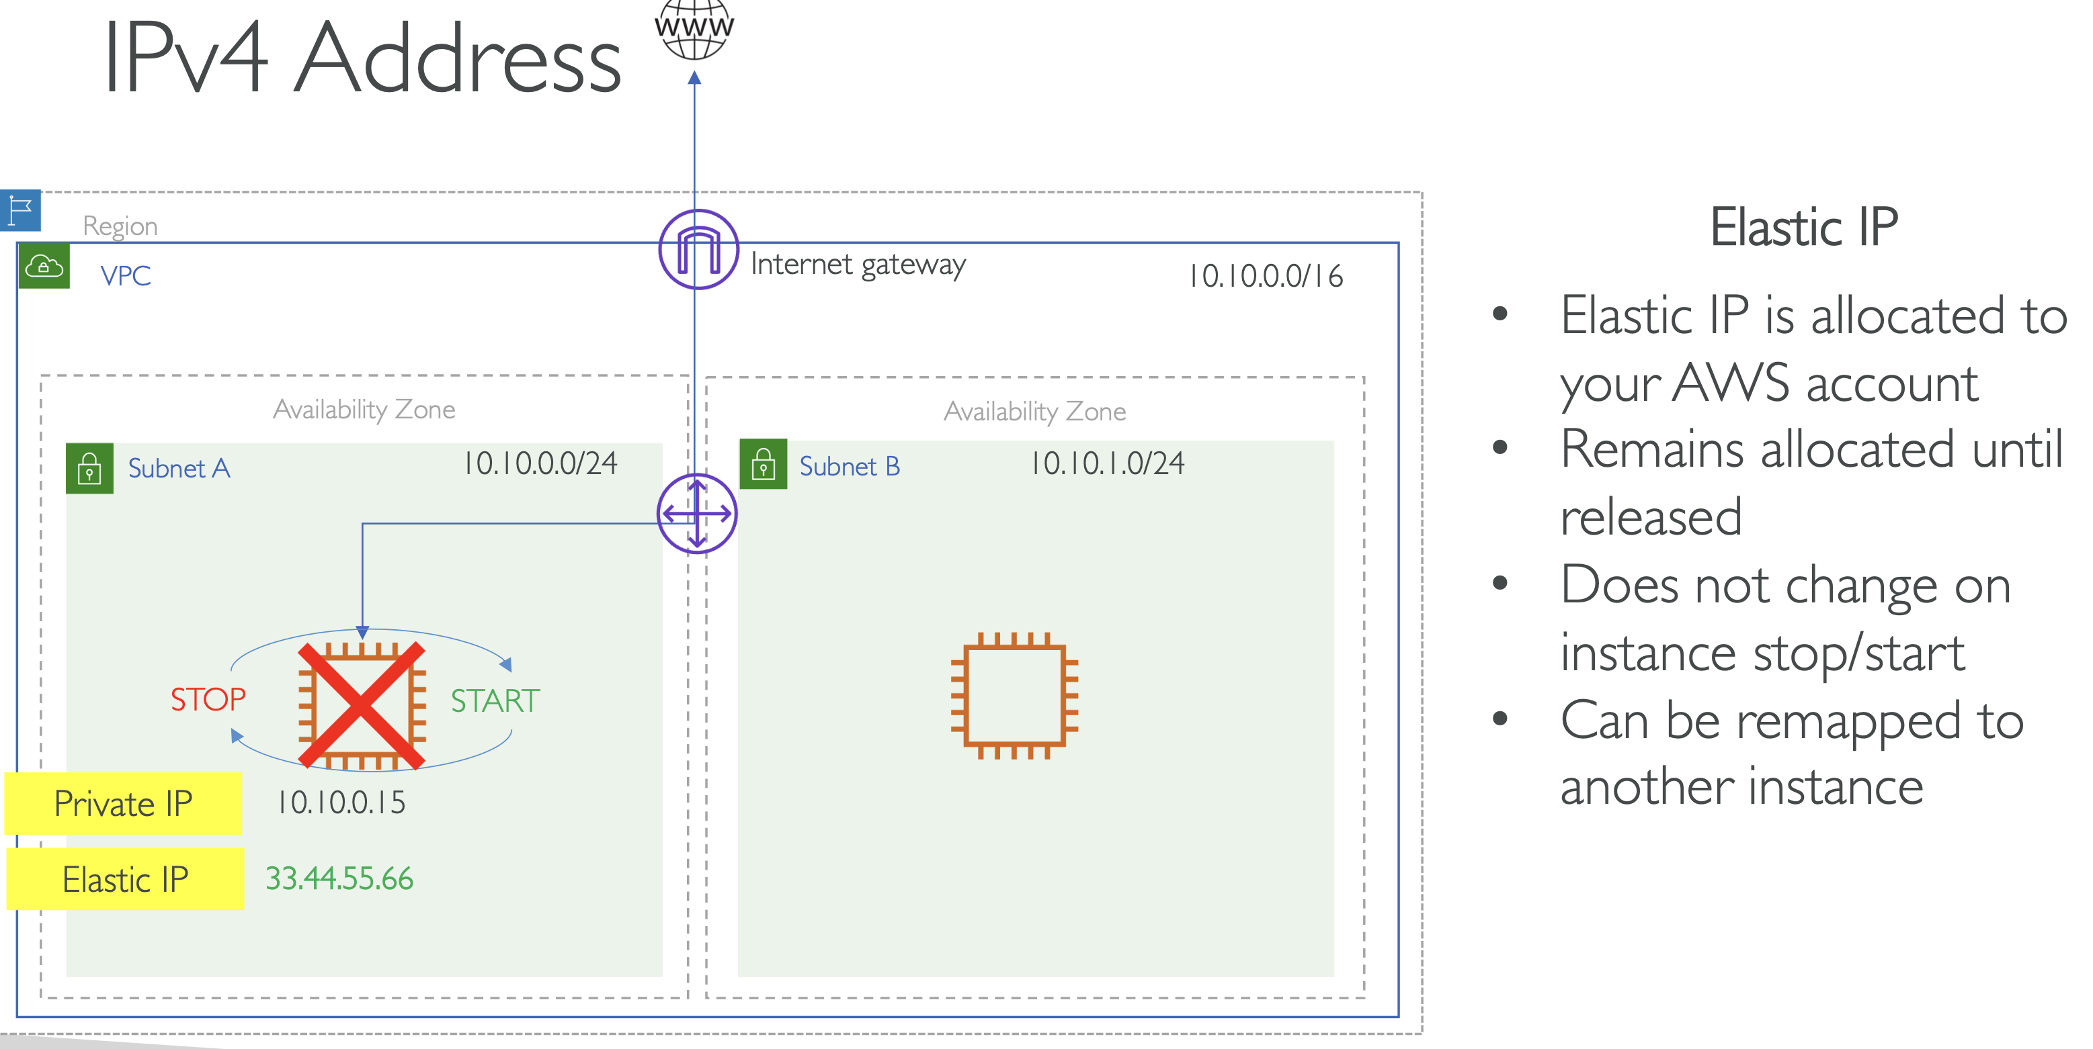

An ENI (Elastic Network Interface) is the network endpoint that Elastic IPs bind to, enabling flexible attachment and movement of public IPs in AWS.

